To update TLS 1.2, the userid must be wsadmin

1. Login to DMGR (Use SIT Env as illustration)

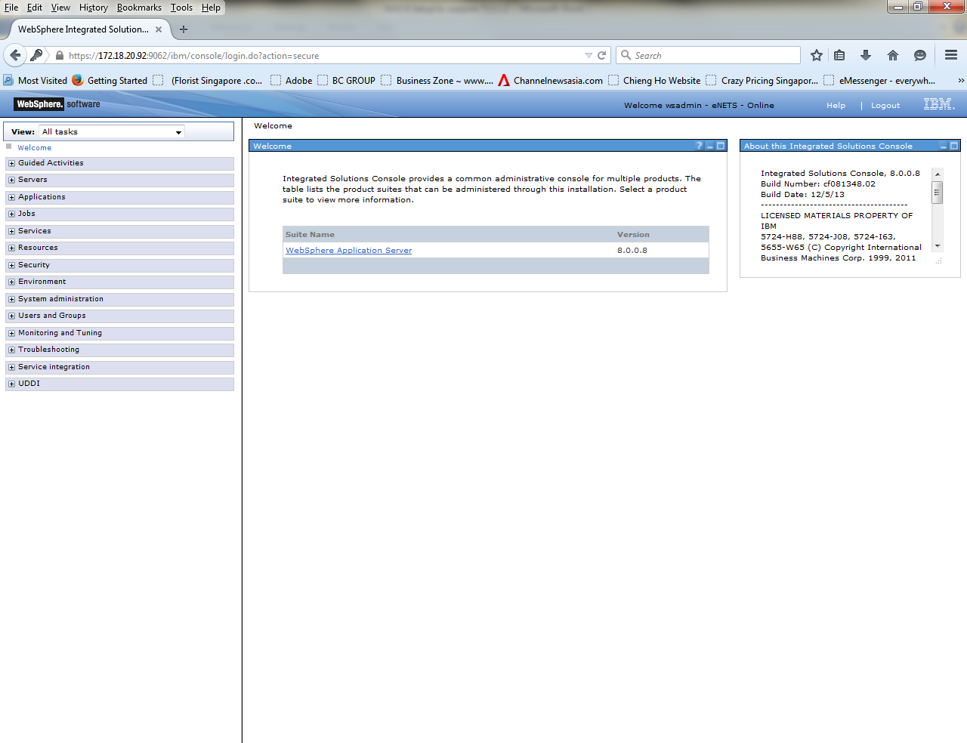

1. Select Security->SSL Certificate & Key Management

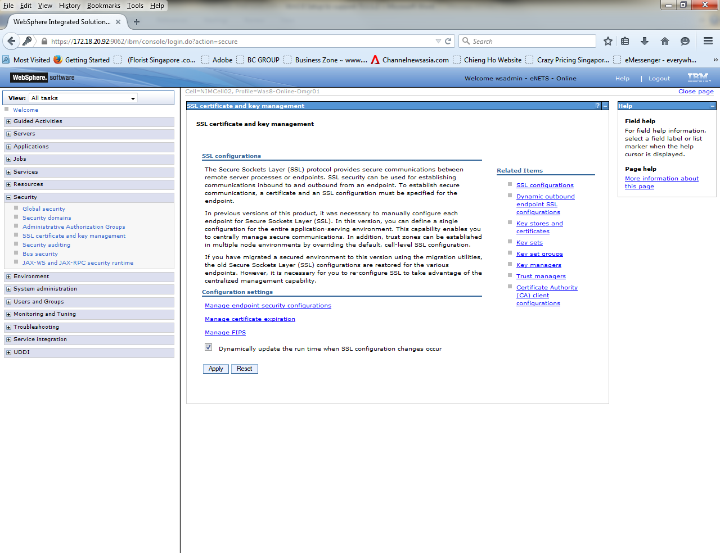

1. Under Configuration settings, click **Manage endpoint security configurations**

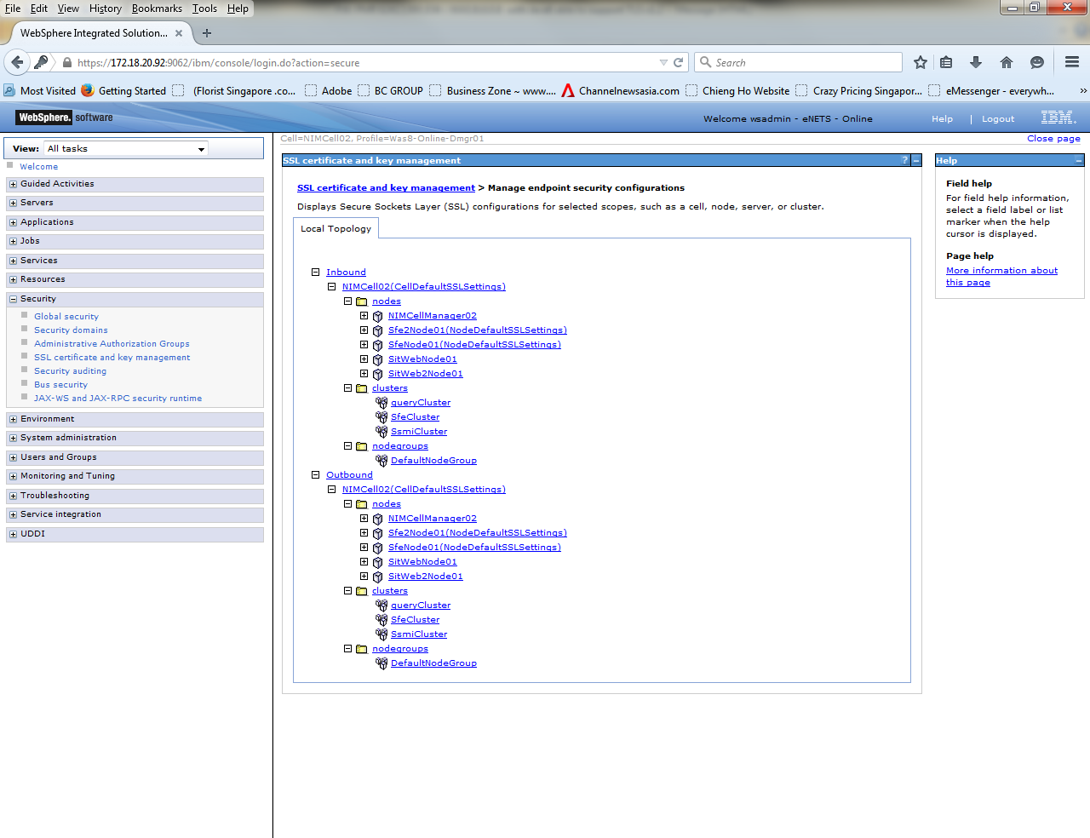

1. Choose Outbound (for Legacy merchant notification )->clusters->Sfe Cluster

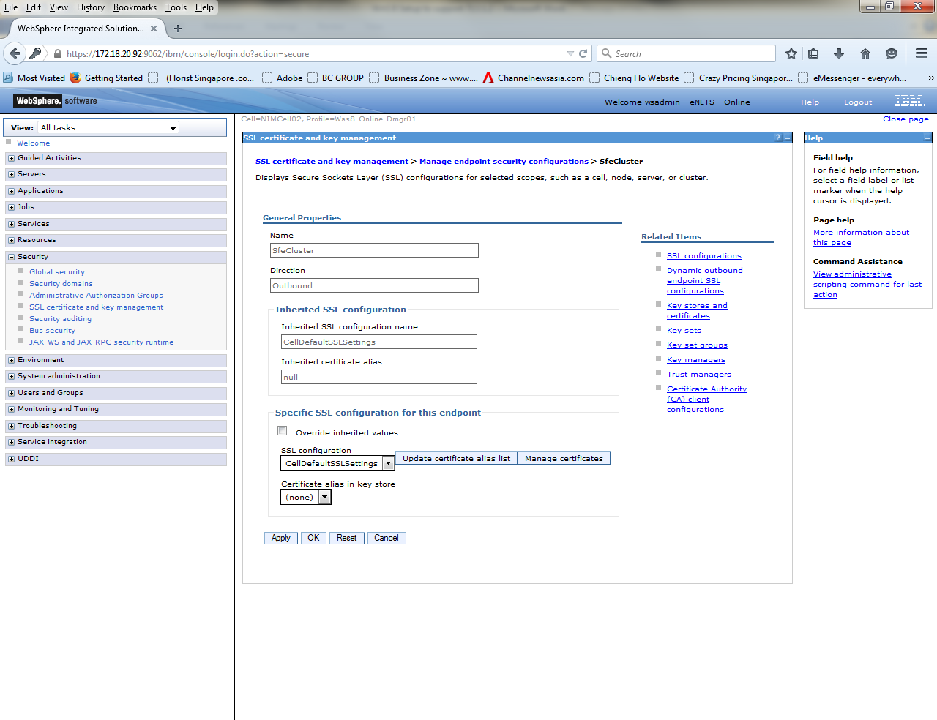

1. Choose SSL Configurations under Related Items

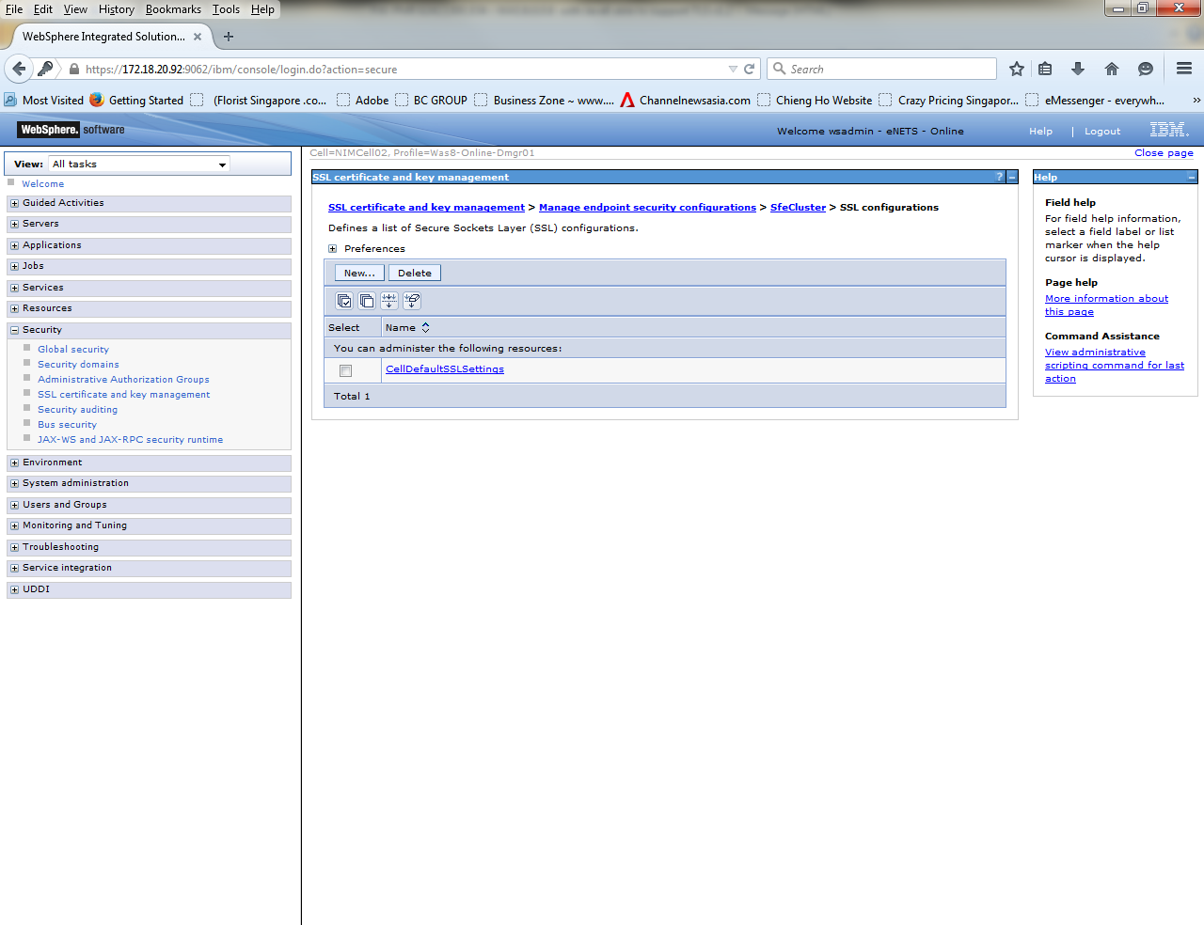

1. Select CellDefaultSSLSettings

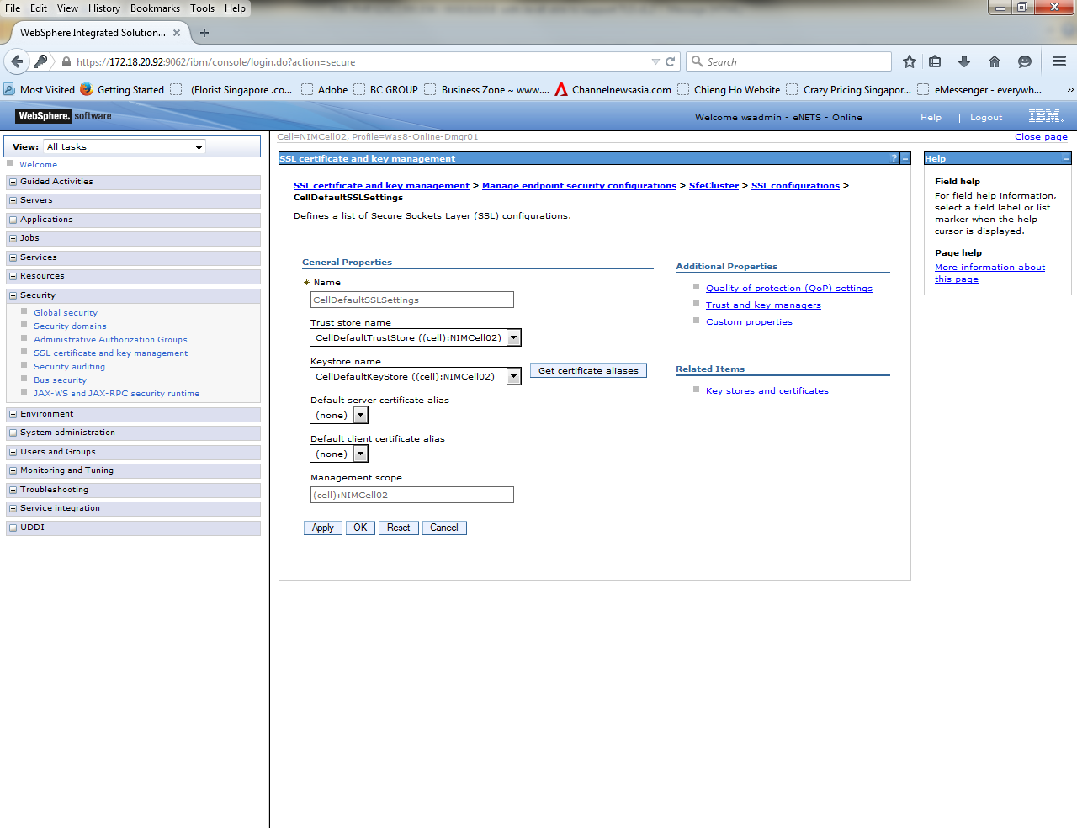

1. Under **Additional Properties**, click **Quality of protection (QoP) settings**.

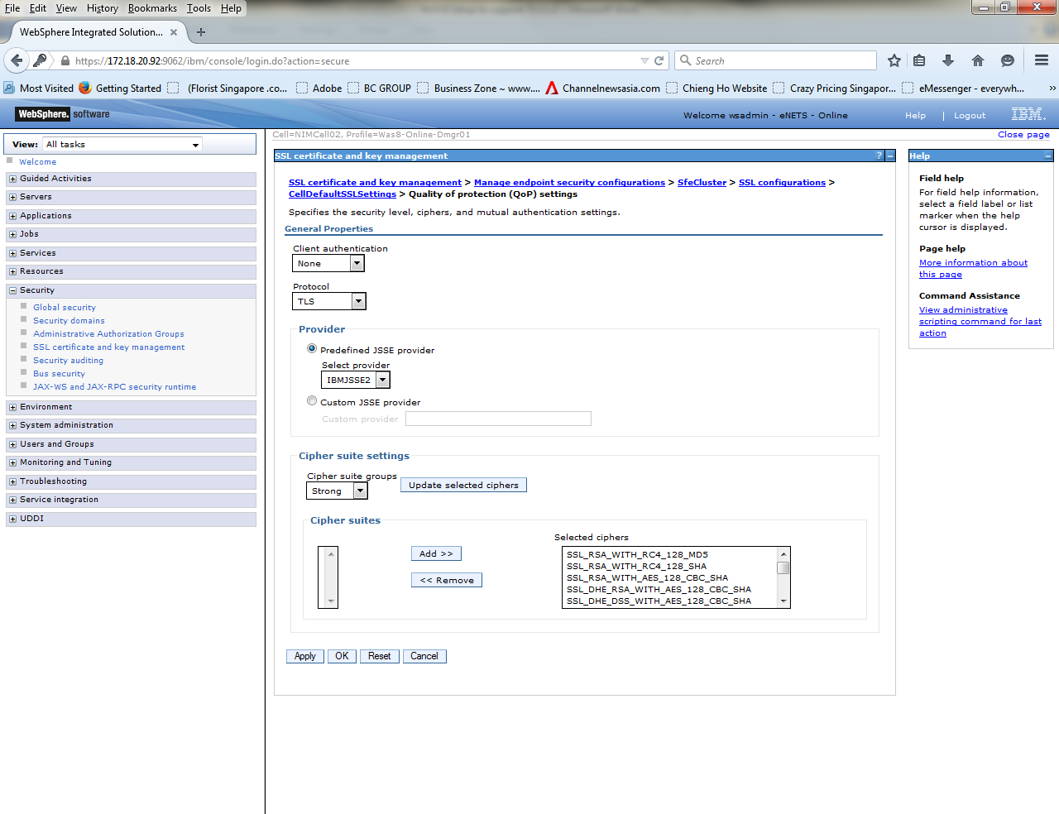

1. Under Protocol , select SSL_TLSv2 (pending confirmation from IBM) & click Apply

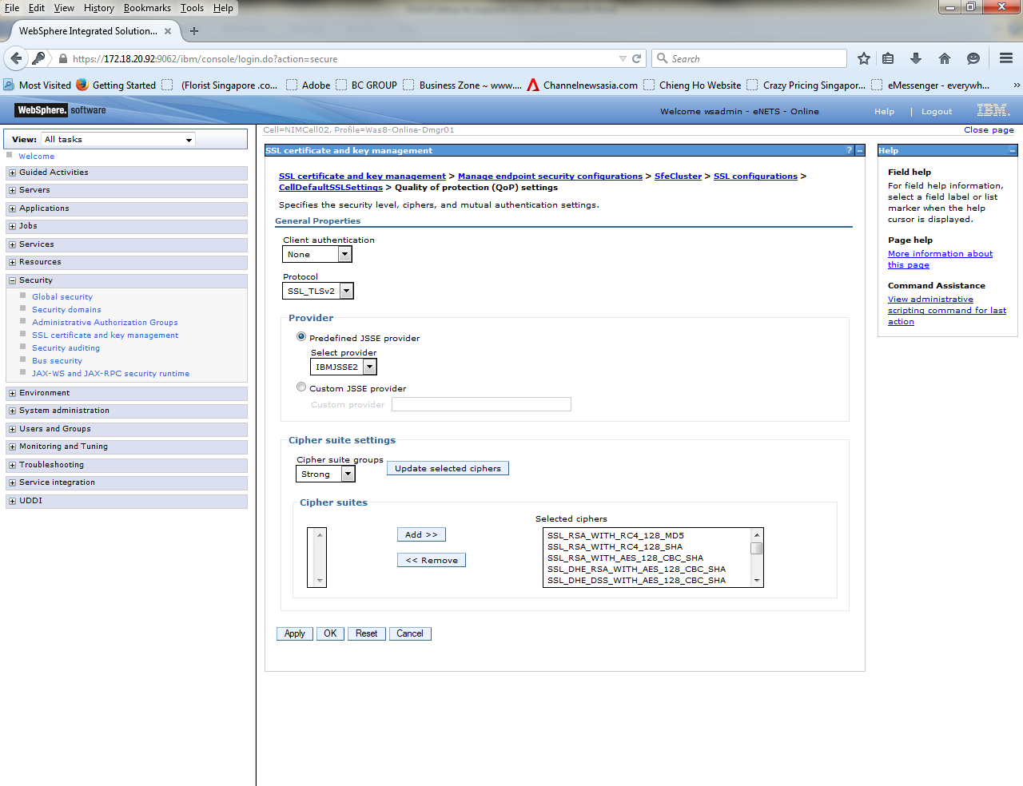

1. Confirmation screen & select Review under Messages

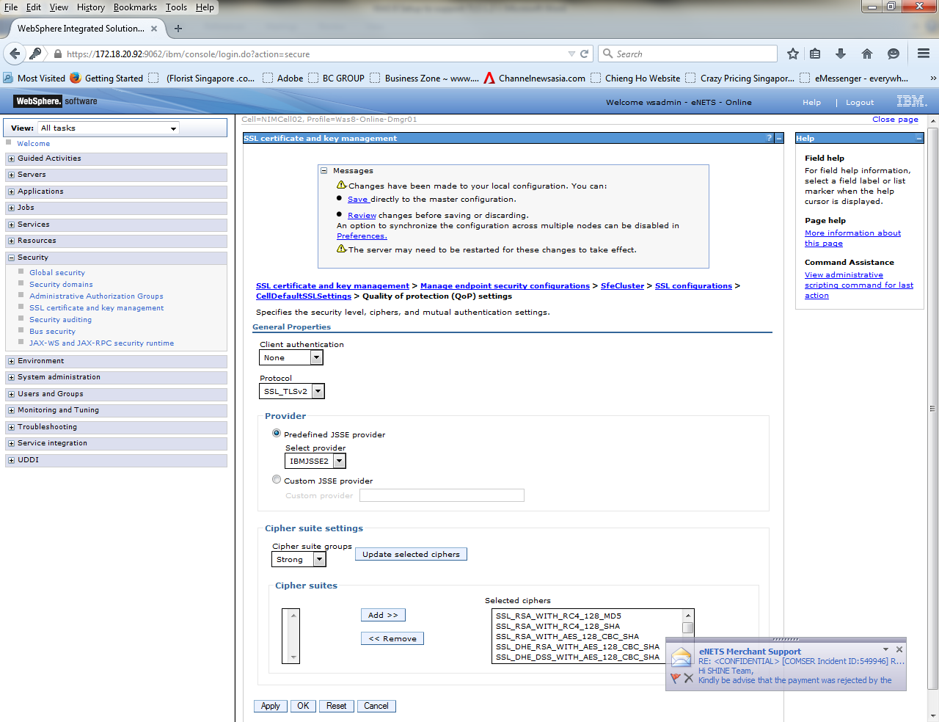

1. Select “Review” changes, uncheck “Synchronize changes with Nodes” since we are doing manual Node sync, then click Save

